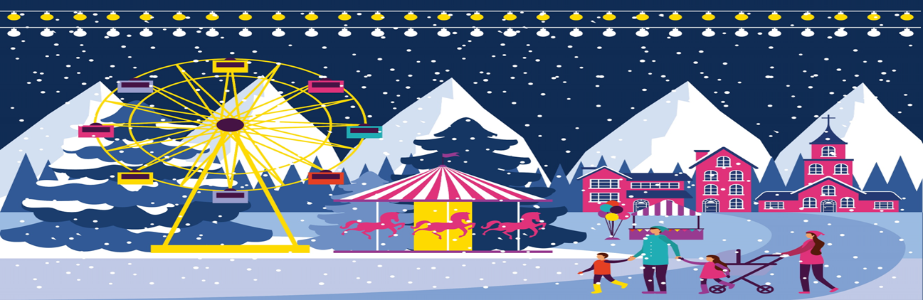
ISSUE NO 1 | 2024 Winter Edition
 | NEWSLETTER  BREEZEWOOD CIVIC ASSOCIATION (BCA)  “Above all, a civic association should be neighbors working together for the common cause of bettering their communities” |  |  |  |  |  |  |  |  | 
Members of BCA Committee Board |  |  |  |  | Contact us via email |  |  |  | Contact President via phone
President: Ed Knotts  Vice President: Amy Saly  Secretary: Angela Lopez  Treasurer: Pam Deputy |  |  |  |  | Info@bcanewark.com |  |  |  | 443.350.2653
Letter from our BCA  I hope you and your family are doing well. Winter is right around the corner and with colder weather approaching us. With the school year in full session please slow down, stop at stop signs, and stop for the school buses with red lights flashing. The speed limit in the neighborhood is 25 MPH.  As a reminder, membership dues are effective from October 2024 – September 2025. The dues are $30/yr per household. The dues pay for snow plowing of the neighborhood, landscaping at the front entrance, and BCA Newsletter distribution.  WE NEED YOUR SUPPORT!  We have a total of 224 homes in Breezewood. We’ve accumulated 3% paid dues that contributed this season. Your support in our neighborhood helps keep it safe for all, retains preservation, and protects your investment. |  |  |  | What the BCA Does?  The BCA is a nonprofit association with volunteers that serve the community by contracting snow plowing and entrance landscaping, holding BCA meetings, hosting BCA community events which include a holiday light contest, arranging for Santa on the Fire truck, Spring Egg Hunt, and network with State and County officials who regularly attend BCA meetings to listen and respond to our collective voices.  UPCOMING EVENTS |  |  |  | Hot Topics  Time to check and clear storm grates in the street in front of your house. Rainwater needs to pass into the sewer system unimpeded. Please clean the debris such as leaves off the grate. Please do not let the debris go down the drain that can cause blockage.  Did you know?   The BCA neighborhood snow removal service requires “at least 4 inches” of snow accumulation for our streets to be plowed.
 |  |  |  | December 11, 2024  BCA Meeting Gauger Middle School  December 20, 2024  Holiday Decorating Contest  December 2024 (date TBD)  Santa on the Fire Truck Neighborhood Drive through |  |  |  | How do you pay dues?  1) Pay via website bcanewark.com or Facebook Breezewood Civic Association.  2) Pay cash or check to Breezewood Civic Association. Drop off to our Treasurer Pam Deputy address:  7 Breezewood Turn Newark, DE

